COSC 290.002

Class Exercise #7

1. Tyrone Shoelaces has invested a huge amount of money into the stock market and doesn’t trust just anyone to give him buying and selling information. Before he will buy a certain stock, he must get input from three sources. His first source is Pain Webster, a famous stockbroker. His second source is Meg A. Cash, a self-made millionaire in the stock market, and his third source is Madame LaZora, world-famous psychic. After several months of receiving advice from all three, he has come to the following conclusions:

a. Buy if Pain and Meg both say Yes and the psychic says No.

b. Buy if the psychic says Yes.

c. Don’t buy otherwise

Construct a truth table and find the minimized Boolean function to implement the logic telling Tyrone when to buy.

2. Analyze the following sequential circuit by determining the truth table. (Complete Output and Next State columns in the truth table.)



|  |  |  |  |
| --- | --- | --- | --- |
| Present State  Z(Q(t)) | Inputs  X Y | Output  S | Next State  Q(t+1) |
| 0 | 0 0 |  |  |
| 0 | 0 1 |  |  |
| 0 | 1 0 |  |  |
| 0 | 1 1 |  |  |
| 1 | 0 0 |  |  |
| 1 | 0 1 |  |  |
| 1 | 1 0 |  |  |
| 1 | 1 1 |  |  |

(Hint: J-K flip-flop characteristic table is as follows:

|  |  |
| --- | --- |
| J K | Q(t+1) |
| 0 0 | Q(t) |
| 0 1 | 0 |
| 1 0 | 1 |
| 1 1 | Q**’**(t) |

1. Analyze the following sequential circuit by determining the table when Count Enable input is 1. (Complete Next State columns in the table.)

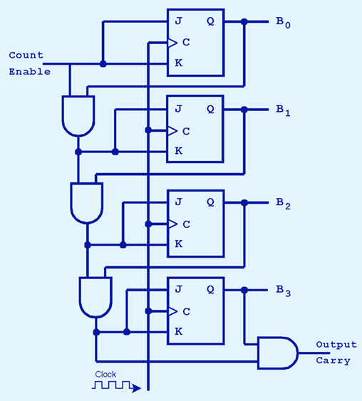

|  |  |
| --- | --- |
| Present State Q(t)  B0 B1 B2 B3 | Next State Q(t+1)  B0 B1 B2 B3 OutputCarry |
| 0 0 0 0 |  |
| 0 0 0 1 |  |
| 0 0 1 1 |  |
| 0 1 0 1 |  |
| 1 0 0 0 |  |
| 1 0 0 1 |  |
| 1 0 1 0 |  |
| 1 1 1 1 |  |